Final Report on the Camping Car Rental System
Name: AMMAR BADRAN BIN MOHD NASIR
Student ID: 22012905

1. Requirements Analysis
Administrator functionality
Administrators can perform the following functions:
- Initialize the database (for example, table regeneration)
- Input, delete, change all tables
  - Deletion/change is performed based on the conditional expression entered by the user, not a single condition

- Full Table View: All records in each table can be viewed
- Check the details of the camper:
  - If you select a camper van, you can check the internal/external maintenance details of the camper van
  - When selecting a part from internal maintenance: displaying the relevant part inventory and supplier information
  - When selecting an external repair shop: Display detailed information about the repair shop

- Ability to execute any SELECT query
  - Allows administrators to enter SQL SELECT queries and view results directly
  - More than 4 tables are joined for testing, 3 or more SELECT queries including Subquery and Group By are tested

General Membership Features
Members can perform the following functions:
- Check the list of camper vans
- Check the rental date of each camper van
- Rent registration for selected campervans and dates
- Check the list of camping cars you rented
- Delete rental history (more than one is possible)
- Change the rental camper to another vehicle
- Change the rental schedule

2. Schema design (based on EER diagrams)
Based on the EER diagram, the following main tables and relationships are designed:
- User: User basic information (username, name, phone, email, password, etc.)
- Customer: Member details (driver's license, address, preferred vehicle, etc.), 1:1 relationship with User
- Company: Camping Car Ownership Company Information
- CamperVan: camper van information (model name, license plate, garden, fuel type, condition, daily charge, etc.)
- Rental: Details of rental (members, vehicle, period, fare, etc.
- Employee: Employee information (name, contact, department, role, etc.)
- Garage: Maintenance shop information
- Maintenance: Maintenance details (vehicle, maintenance type, date, cost, personnel, etc.)
- Supplier: Parts Supplier Information
- Part: Parts information (name, unit price, inventory, etc.)
- Part Usage: Part history used during maintenance

Screen shot of the EER diagram 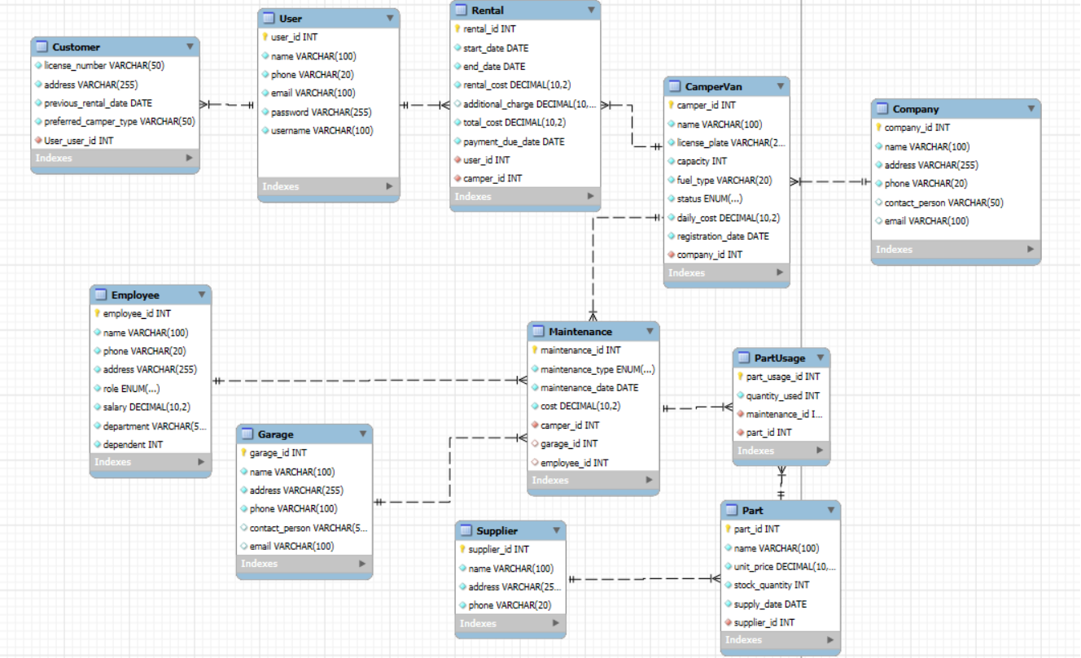

3. Program structure
- Main.java: Program start points, create main frame, and display login screen
- DBConnection.java: Managing MySQL Connections
- LoginScreen.java: Login UI (administrator/member selection, authentication processing)
- AdminPanel.java: Administrator Features UI
- CamperVanPanel.java: Camping Car Inquiry UI
- Includes CRUD for each table (administrator only)

4. How to Test
Administrator Functionality Test
- Verify table regeneration and constraints with DB initialization button
- Check CRUD behaviour of each table (input, delete, modify)
- Check flexible deletion/modification behaviour with conditional input
- Select a camper van → Check internal/external maintenance details → Check parts/maintenance shop details
- Direct SQL input → display results (including exceptional processing)
- Composite SQL Test Query:

1. 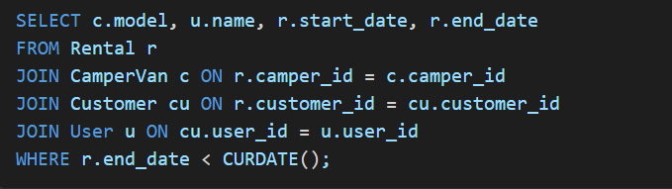

2.
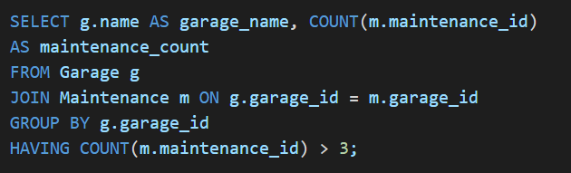
3.
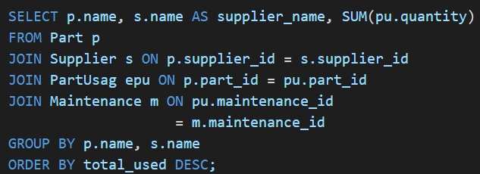

5. Member Function Test
- Check camper car list normal after logging in
- Check the rental available date function test
- Check normal behaviour for each scenario when registering to rent a camper van
- Inquiry of personal rental history and deletion/modification test (including vehicle or date change)
- Mechanical Maintenance Request Registration Function Test

6. Conclusions and other matters
- Configuring UI based on Java Swing, separating functions by panel
- DB connection information is for testing root/1234 (security is required in real service)
- Set PK/FK/UNIQUE constraints on all tables → ensure integrity
Structuring code and SQL considering maintenance and scaling

